Web accessibility of Ubuntu.com

## Tests using online accessibilty tools

We tested the accessibility of ubuntu.com using the Web Accessibilty Checker at <http://achecker.ca/checker/index.php> and the Center for Persons with Disabilities’ WAVE Web Accessibility Tool at <http://wave.webaim.org>. Both tools examine HTML pages for a number of accessiblity issues poor semantic structure, poor contrast between foreground text and background colour, and conformance with HTML and CSS standards. Both tools passed ubuntu.com on HTML and CSS standards.

The Web Accessibilty Checker detected a problem with the main page’s images. Most of them did not have alt text. This is especially a problem for the Unbuntu logo because it is also a link. This same problem ocurred on most Ubuntu pages.

The WAVE Web Accessibility Tool found no major problems with Ubuntu.com but found some issues that might affect people with colour impairments (discussed in the Color impaired users section below).

## Tests using screen readers

The Ubuntu site was tested using two screen readers: Windows’ Narrator and JAWS (Job Access With Speech). Both readers revealed potental problems.

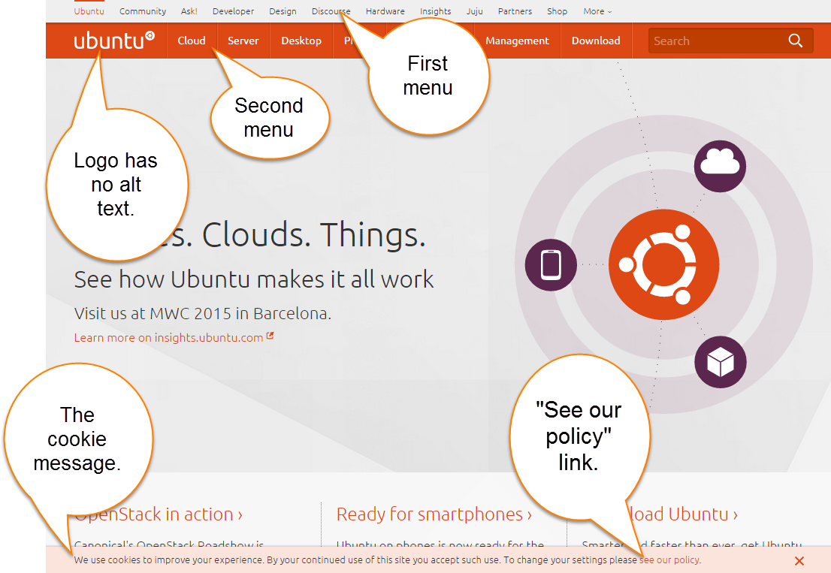

Figure 1. www.ubuntu.com/index

Using a screen reader you hear the screen in this order:

1. title of the page
2. first menu, one item at a time (see figure 1)
3. the cookie message at the the bottom of the screen
4. a “Jump to content” link
5. the second menu.
6. The Jumbotron and 3 sub panels (see figure 2).

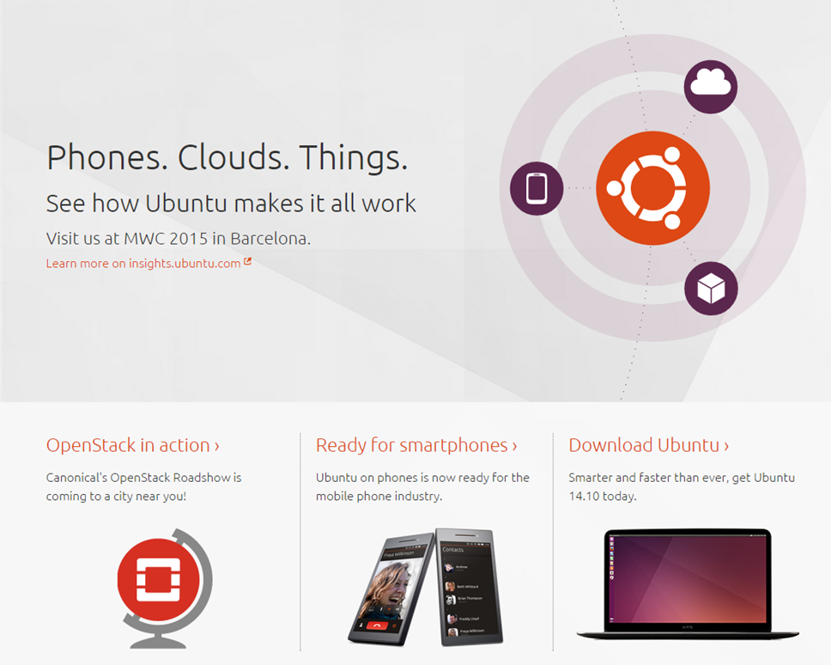

Figure 2. The "Jumbton" and 3 sub-panels

There is a hidden “Jump to content” link that allows you to skip ahead to the main content of the screen. Usually this is placed before the main menu. On the Ubuntu site you have to listen to 11 menu items before you can find that link. It is better for the visually impaired users if it is the first item they hear, but on the Ubuntu site it is placed between the first and second menus. This would be very confusing for people using screen readers.

Peole who cannot use a mouse will have difficulties with Ubuntu.com. Typically people who cannot use a mouse use the tab key to access links. Some individuals who cannot use a mouse have to use a mouthstick to press the tab key to navigate web pages. To get to a link on the main content area (the Jumbotron) on the Ubuntu page you have to click tab 25 times. If they are using a screen reader, they would have to click tab only 15 times because of the hidden “Jump to content” link. That is too many.

Accessible sites like CNIB.ca have a link to the main content as the first visible link on their page (see figure 3). This means people using screen readers or mouth sticks can access the main content right away. People who cannot use a mouse can see a link to the main content and use it as a shortcut to the main content.

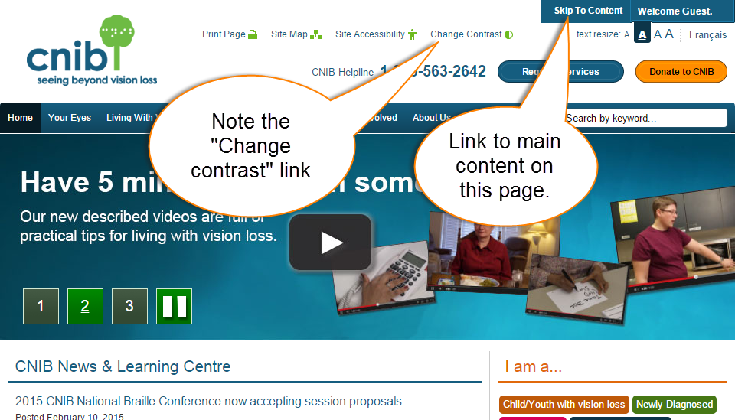

Figure 3. CNIB website.

The Ubuntu website should also make more careful consideration about how they word their links. For example, In the cookies message at the bottom of the screen, the link to the privacy policy says “see our policy” (see figure 1). It is difficult to know what policy they mean, especially when some screen readers, such as Windows Narrator, cannot read the other text in the cookie message window. The link should be rewritten as “See our privacy policy” or “See our cookie policy”.

The cookie message also hijacks some screen readers. That is, it has the highest z-index and appears infront of the rest of the text on the bottom of the screen. Because of this screen readers jump right that text after reading the first menu at the top of the page. This effect might be intentional, but it is confusing.

## Color impaired users

At first glance there seems to be enough contrast between the foregroud text and backgroung colours on the Ubuntu site. One of our team members is colour blind and had no problems with reading the content on the site. However, according to <http://www.checkmycolours.com> there might be some concerns. They found that the contrast between the text and some of the background colours was too low. The Center for Persons with Disabilities’ WAVE Web Accessibility Tool at <http://wave.webaim.org/> also found the contrast to be too low on 17 elements on Ubuntu’s index page.

## Conclusion

In conclusion, the Ubuntu.com website has made some attempts at accessibility. They added alt text to many of their images. They follow CSS and HTML standards which makes it easier for screen reader users to navigate their page. They also included a link that allows screen reader users to skip to the main content.

There were some unaddressed accessibilty issues on their site.

1. The link to skip to main content was poorly placed and inaccessible to peole who cannot use a mouse. It should be the first link on the page and visible.
2. The cookie message hijacks screen readers and its link should be re-worded.
3. Not all of their links had alt text, including their logo which is a link.
4. There are 92 links on the index page which makes it a challenge for some print impaired individuals to navigate. A visible link to the main conten would help by providing a short cut past the navigation menus.
5. There are concerns that there is not enough contrast between the text and the background colour. A high contrast option, like the one on the CNIB.ca page would solve this problem.

Most of these issues can be easily fixed. Websites like the Center for Persons with Disabilities (<http://webaim.org> ) and the CNIB (<http://cnib.ca> ) have information on how these issues affect individuals and how to make sites more accessible. Ideally they could also find someone who uses a screen reader or who cannot use a mouse and ask them to test their site for them.